
EXSAFE PRODUCT OVERVIEW
Marine Valve Supply Range for Shipbuilding, Repair and Fleet Operations
High Velocity P/V Valves | Regulating Valves | Air Vent Heads | Marine Valves | Strainers | Piping Accessories | Fabrication Services
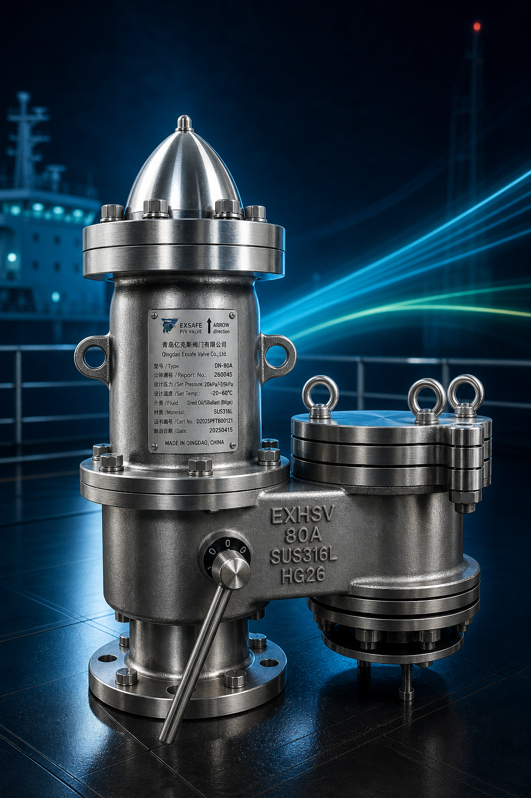 | 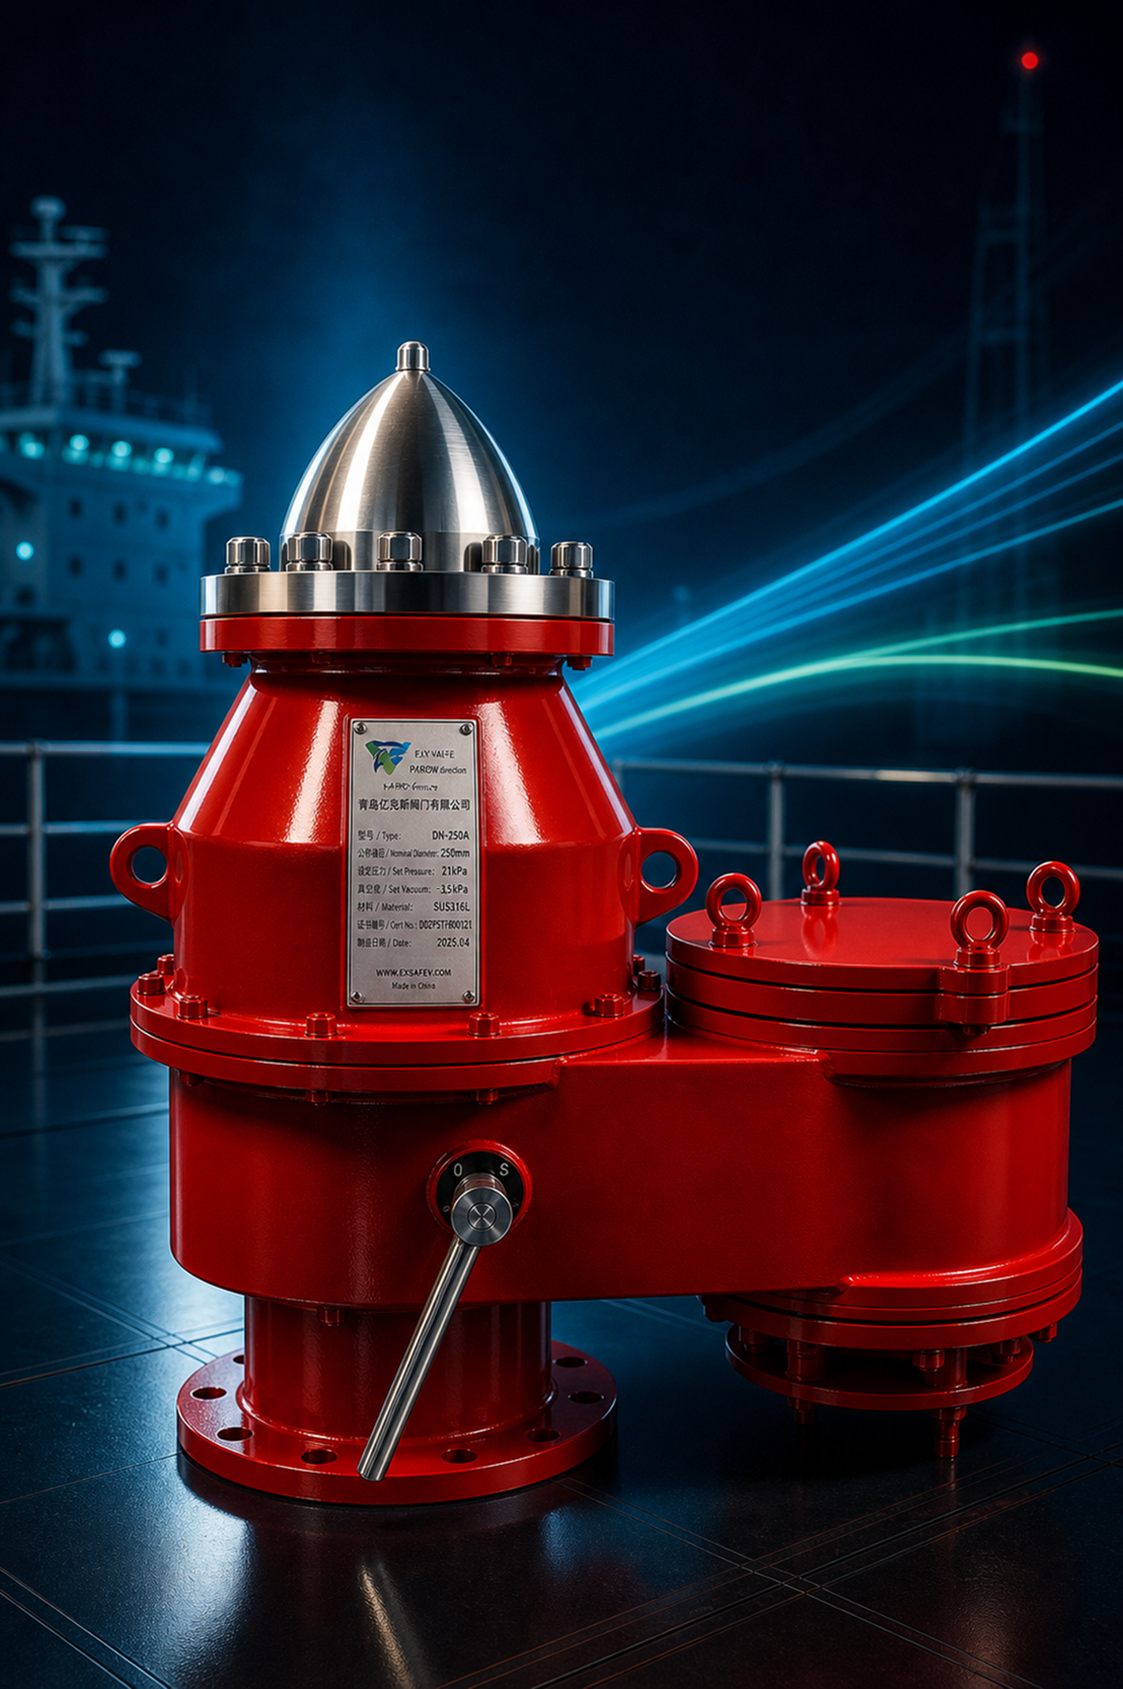

Positioning
Since 1995, Qingdao Exsafe Valve Co., Ltd. has been engaged in marine valve manufacturing. Exsafe supplies class-approved P/V valves, marine valves, air vent heads and customized components for shipyards, shipowners, ship managers and repair projects.

1. Product Overview
Qingdao Exsafe Valve Co., Ltd. provides a comprehensive marine valve supply range for shipbuilding, ship repair, retrofit projects and fleet operations. As a factory with workshops, equipment and experienced personnel, Exsafe can support both standard marine valve supply and customized fabrication, forging and machining services.
Category | Main Offering | Typical Customers
P/V Valves | High Velocity P/V Valves and Explosion-Proof Electric P/V Valves | Tanker owners, shipyards, ship managers, system integrators
Regulating Valves | Flow, pressure and system control valves for shipboard applications | Shipyards, repair yards, engine room and piping system contractors
Air Vent Heads | Air pipe heads and venting products for ballast, fuel, fresh water and cargo systems | Shipyards, ship repair projects, fleet spare parts teams
Marine Valves | General shipboard valves aligned with IMPA 75xxxx valve/cock procurement families | Shipowners, ship managers, purchasing departments, repair yards
Strainers / Filters | Mud boxes, strainers, filters and related flow protection components | Engine room, seawater, ballast, fuel and pipeline systems
Piping Accessories | Flanges, elbows, tees, reducers, gaskets, fasteners, pipe fittings and accessories | Ship repair, retrofit and piping installation projects
Fabrication / Forging / Machining | Custom parts, machined components, forged parts, welded fabrication and repair support | Shipyards, OEM partners, repair yards, industrial customers

2. High Velocity P/V Valves
The High Velocity P/V Valve is Exsafe's core product. It is designed for cargo tank venting systems where pressure protection, flame prevention, sealing performance and stable operation are critical.
- Wide-body fluid-dynamic design for stable opening
- Non-oscillation and non-hammering performance
- Metal-to-metal sealing with zero-leakage target
- No magnets and no periodic magnet replacement
- Low blowdown to reduce unnecessary venting and VOC loss
- Custom pressure range: 5-100 kPa
- Material options: FCD / WCB / SUS304 / SUS316L
Website Message
Stable by Fluid Dynamics, not by Magnets.

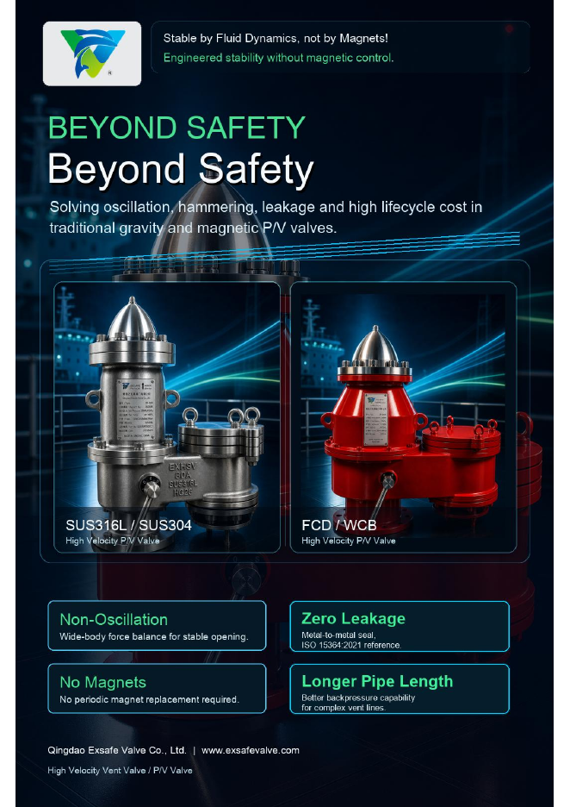
High Velocity P/V Valve - core product and technology focus
3. Regulating Valves
Exsafe supplies regulating valves for shipboard systems where flow, pressure or operating conditions need to be controlled. These products support marine piping systems, engine room systems, auxiliary systems and repair replacement demand.
- Flow control and pressure control applications
- Manual, pneumatic or project-specific actuation options depending on requirement
- Suitable for seawater, fresh water, fuel, oil, air and general shipboard media
- Support for repair replacement, project supply and customized system requirements
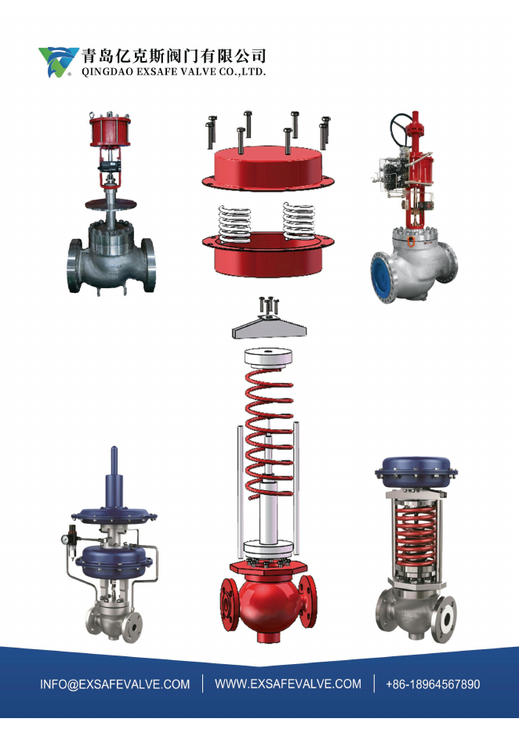
Regulating valves and control-related marine valve products
4. Air Vent Heads
Air vent heads are widely used on ships for tanks and piping systems requiring reliable venting and anti-splash protection. Exsafe supplies air vent heads for newbuilding, ship repair and spare part replacement projects.
- For ballast tanks, fuel oil tanks, fresh water tanks, cargo-related tanks and general venting systems
- Lightweight, corrosion-resistant and low-maintenance design options
- Options may include insect screen, flame arrester, special flange size and special connection screw
- Suitable for shipyard standard supply and fleet spare part demand
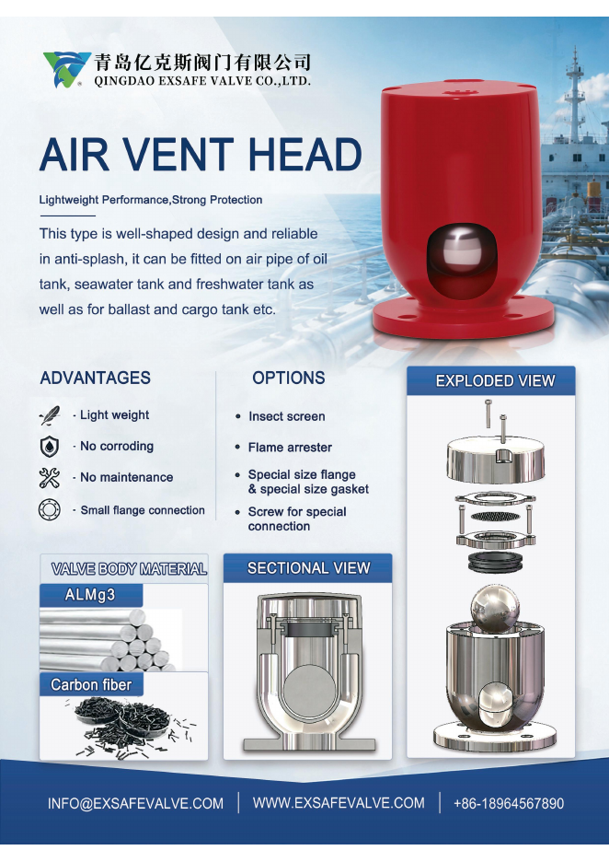
Air Vent Head product range
5. Marine Valves - IMPA 75xxxx Related Supply
Exsafe supplies general marine valves commonly requested by shipowners, ship managers and shipyards. This category can be organized to support IMPA 75xxxx valve/cock procurement families, helping purchasing teams identify standard shipboard valve requirements more efficiently.
IMPA Note
For website wording, use “aligned with IMPA 75xxxx valve/cock procurement families” rather than listing exact codes unless the final code list is checked against the latest IMPA Marine Stores Guide.

Product Family | Typical Products
Gate Valves | Marine gate valves for seawater, ballast, bilge, fuel and general piping systems
Globe Valves | Marine globe valves for flow isolation and throttling applications
Check / Non-Return Valves | Swing check valves, lift check valves and non-return valves
Butterfly Valves | Wafer, lug and flanged butterfly valves for shipboard piping systems
Ball Valves | Threaded, flanged and special-purpose marine ball valves
Storm Valves | Storm valves and overboard discharge valves
Safety / Relief Valves | Safety valves, relief valves and pressure reducing valves
Special Marine Valves | Hose valves, self-closing drain valves, emergency shut-off valves and project-specific valves

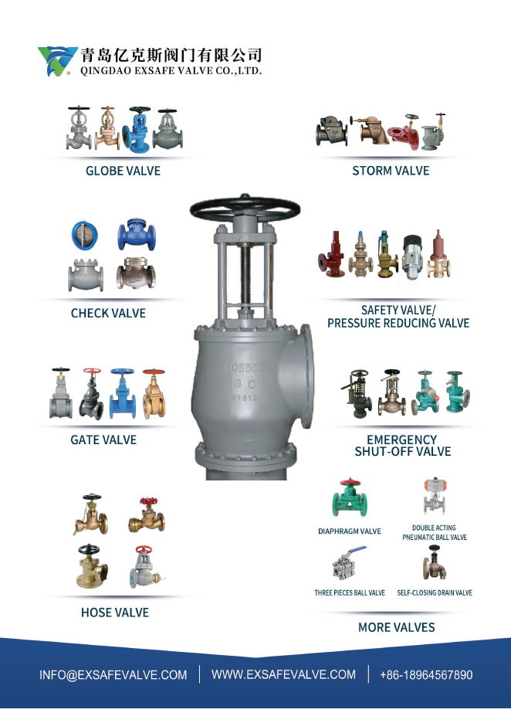
Marine valve product range aligned with common shipboard valve procurement
6. Strainers and Filters
Strainers and filters protect shipboard equipment and piping systems from impurities, particles and flow contamination. Exsafe can support standard and customized strainer/filter requirements for marine systems.
- Y-type strainers
- Basket strainers
- Mud boxes
- Duplex filters and project-specific filter arrangements
- Suitable for seawater, ballast, cooling, fuel, oil and general piping systems
- Support for customized connection, material and mesh/screen requirements
7. Piping Accessories
Exsafe can provide piping accessories for shipbuilding, ship repair and retrofit projects. These products help customers consolidate procurement and reduce coordination work during repair docking or project installation.
- Flanges
- Elbows, tees and reducers
- Pipe fittings and adaptors
- Gaskets, bolts, nuts and fasteners
- Flexible connectors and expansion joints
- Pipe supports and customized accessories
- Standard and project-specific materials and dimensions
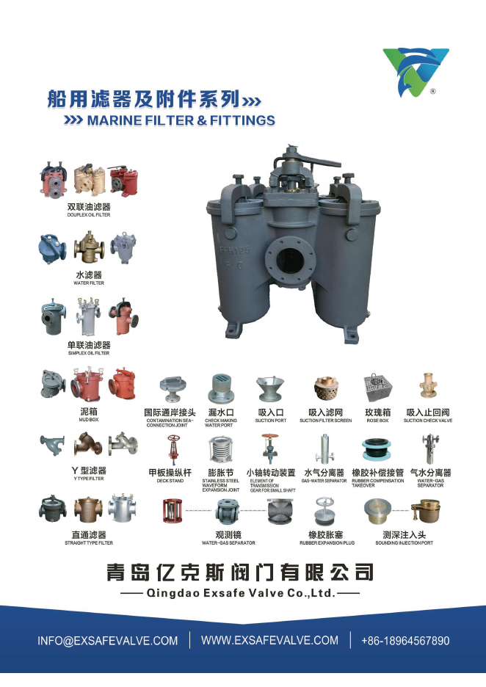
Piping accessories, fittings and marine-related supply items
8. Fabrication, Forging and Machining Services
As a factory with workshops, equipment and skilled personnel, Exsafe can also support fabrication, forging and machining services. This capability is valuable for customers who need customized components, urgent repair parts or project-specific manufacturing support.
- Machining of valve bodies, seats, discs, stems and customized components
- Forged parts and machined fittings based on drawings or samples
- Welded fabrication and structural/pipe-related components
- Custom flanges, adaptors, covers and repair parts
- Small-batch and project-specific manufacturing support
- OEM and subcontract manufacturing cooperation
Website Message
Beyond standard product supply, Exsafe can support customized manufacturing because we are a real factory with workshop capability, equipment and experienced people.

9. Recommended Website Product Navigation
Website Menu | Recommended Page Focus
High Velocity P/V Valve | Core technology, non-oscillation, sealing, materials, pressure range and certificates
Explosion-Proof Electric P/V Valve | Special applications, explosion-proof function, low-temperature or electric-control requirements
Regulating Valve | Control-related marine valve applications and customized requirements
Air Vent Head | Tank venting, anti-splash design, materials and options
Marine Valve | IMPA 75xxxx-related valve/cock families and general shipboard valve supply
Strainers & Filters | Flow protection products for shipboard piping systems
Piping Accessories | Fittings, flanges, gaskets, fasteners and project accessories
Fabrication Services | Machining, forging, welding fabrication and customized manufacturing

10. Footer Copy for Product Pages
Suggested Footer
Qingdao Exsafe Valve Co., Ltd.
High Velocity P/V Valves | Marine Valves | Air Vent Heads | Strainers | Piping Accessories | Fabrication Services
Website: www.exsafevalve.com
Email: Peter@exsafevalve.com
Slogan: Beyond Safety

